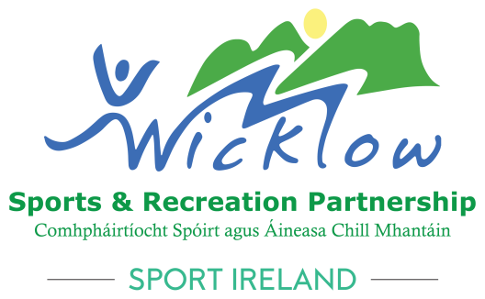

**Wicklow Sports & Recreation Partnership**

**Club Development Grant Scheme 2024**

.

|  |
| --- |
| **\*\*\*\*\*Closing date Wednesday, March 20th 2024\*\*\*\*\***  Please email your application to [Wicklowlsp@wicklowcoco.ie](mailto:Wicklowlsp@wicklowcoco.ie) with  **“Club Development Grant Scheme 2024”**in the subject bar. |

# Wicklow Sports & Recreation Partnership

# Club Development Grant Scheme 2024

One of the aims of Wicklow Sports & Recreation Partnership is to support sports clubs to provide opportunities for people to participate in organised sport and physical activity. This Club Development Grant Scheme aims to support initiatives that will lead to an increase in participation levels in sports clubs across Wicklow.

This scheme is aimed at **sports clubs** who are affiliated to a [National Governing Body](https://www.sportireland.ie/national-governing-bodies/ngb-contact-finder) that is recognised by Sport Ireland.

### This scheme will have a focus on the following:

* Training and education of club volunteers.
* Delivery of programmes or initiatives that will increase club membership.
* Small equipment purchases to facilitate increased membership or developing a new section of the club, e.g. a female, youth or inclusive section.
* Youth development programmes to support the youth section of the club by training or upskilling the youth members.
* Programmes or initiatives with a focus on inclusion of new communities, women, or those with disabilities.

|  |
| --- |
| **Please note: There will be a maximum allocation of €1,500 per club.** |

### What will NOT be funded and who is INELIGIBLE?

* Funding will not be available for day to day expenses of clubs (electricity bills, heating costs etc.).
* Funding will not be available for jerseys or uniforms.
* Club trips will not be funded.
* Only sports clubs who are affiliated to a [National Governing Body](https://www.sportireland.ie/national-governing-bodies/ngb-contact-finder) that is recognised by Sport Ireland will be elligible.
* Clubs must be non for profit.

### Examples of what might be included (the below are only samples of what might be included).

* Rolling out a National Governing body initiative in your club to attract new members.
* Running a Volunteer recruitment/training programme.
* Upskilling current members, especially in the youth section.
* Small modification to your facilities to be more inclusive and accessible.
* Singage in the club.
* Translation of your advertisements and application forms to include new populations in your area.
* Delivering a youth development initiative.
* Making your club Autism friendly.
* Equipment targeted at specific populations (that are not currently engaged with your club)
* New player recruitment programme.
* Older adult engagement in your clubhouse.

**Application form - Club Development Grant Scheme 2024**

***Club Details:***

|  |
| --- |
|  |

Name of Club:

Address of Club:

|  |
| --- |
|  |

|  |
| --- |
|  |

Eircode:

Sport: ____________________ National Governing Body: _______________________

Name of Lead Applicant:_______________________________________

Contact Details: Phone: ______________________________________________

Email: ______________________________________________

Name of Chairperson: _________________________________

Contact Details: Phone: ______________________________________________

Email: ______________________________________________

Name of Secretary: _________________________________

Contact Details: Phone: ______________________________________________

Email: ______________________________________________

**********************************************************************************

**Overview of your Project:**

Please give a description of your project below.

|  |
| --- |
|  |

How did you assess the need for this project in your club?

|  |
| --- |
|  |

Who is your project going to target?

|  |
| --- |
|  |

What is the cost breakdown of your project?

|  |
| --- |
|  |

What will your club contribute towards the project?

(Please include both financial investment and volunteer time and expertise and club resources)

|  |
| --- |
|  |

How will this project impact your club & how sustainable is this project?

|  |
| --- |
|  |

How much financial support are you seeking from Wicklow Sports & Recreation Partnership?

|  |
| --- |
|  |

*Please supply any supporting documentation that you think will help your application.*

|  |
| --- |
| **\*\*\*\*\*Closing date Wednesday, 20th March 2024\*\*\*\*\***  Please email your application to [Wicklowlsp@wicklowcoco.ie](mailto:Wicklowlsp@wicklowcoco.ie) with  **“Club Development Grant Scheme 2024”**in the subject bar. |

### Terms and Conditions for successful projects:

* Receipts as proof of payment will be required to be submitted.
* Proof of Bank Account is required.
* The names and roles of the Executive of your club will need to be submitted.
* A signed declaration must be submitted, this will be supplied by Wicklow SRP to successful applicants.

No payments will be made until T&C’s are fully abided by.

On signing the below, you agree to the terms and conditions above and confirm that all information on this form is true and correct.

Signed: ______________________________________________

Name (Block Capitals): _________________________________

**Chairperson/Secretary**