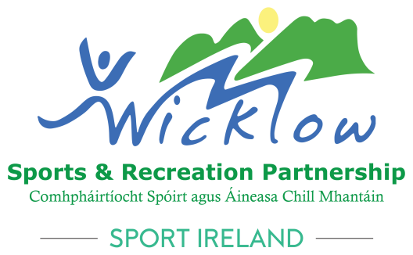

Wicklow Sports & Recreation Partnership

Community COVID Restart Grant 2022

***** Closing Date Friday 23rd September 2022*****

Wicklow Sports & Recreation Partnerships
Community COVID Restart Grant 2022

Aim of the Community Covid Restart Grant 2022?
To assist Community Groups who deliver sport and physical activity programmes and provide minority sports clubs with assistance to cover costs associated with returning to activity.
The total amount awarded cannot exceed €1,500.

What will NOT be funded and who is INELIGIBLE?
- Any Club or Community group that have previously received COVID 19 supports through Wicklow Sports & Recreation Partnership or a National Governing Body of Sport will NOT be funded again.
- Anything that is not COVID 19 related will not be funded.

Examples of what might be included (the below are only samples of what might be included)
What costs can be applied for?
- Increased venue hire costs to comply with social distancing
- Insurance Costs
- COVID-19 Related Costs for Hygiene Consumables (E.g. Hand sanitizer, soap, face masks, gloves etc.)
- COVID-19 Related Infrastructure Costs (E.g. Plexiglass screens, wall mounted dispensers, signage)
- COVID-19 Related venue/equipment cleaning costs
- COVID-19 Related Volunteer Training Costs
- COVID-19 Related Staff Training Costs
- Additional Registration/ Event Management Costs (E.g. admin or IT costs to manage self-declarations)
- Small modification to your facility for safety and to allow social distancing i.e. screens in communal areas / Partitions up between changing areas in changing rooms etc.
- Singage in the community centre or club
- Fogging machines / Disinfectant foggers
- Equipment to allow for outdoor training/physical activity
Receipts can be dated from 1st January 2022

Who can apply?
(A) Community Groups who deliver sport and physical activity programmes
(B) Sports Clubs who are NOT affiliated to a National Governing Body of Sport (NGB’s)
(C) Minority Sports Clubs whose NGB is not listed below:
The following is a list of NGB’s that are administering Covid restart grants to their affiliated clubs. Clubs are advised to contact their NGB for further information:
- American Football Ireland
- Archery Ireland
- Athletics Ireland
- Basketball Ireland
- Bol Chumann na hÉireann
- Bowling League of Ireland
- Camogie Association
- Canoeing Ireland
- Cricket Ireland
- Diving Ireland
- FAI
- Fencing Ireland
- GAA
- GAA Handball Ireland
- Golf Ireland
- Gymnastics Ireland
- Hockey Ireland
- Horse Sport Ireland
- IRFU
- Irish Athletic Boxing Association
- Irish Judo Association
- Irish Martial Arts Commission
- Irish Sailing Association
- Irish Squash
- Irish Taekwondo Union
- Ladies Gaelic Football Association
- Motor Sport Ireland
- Mountaineering Ireland
- ONAKAI
- Rowing Ireland
- Rugby League Ireland
- Special Olympics Ireland
- Swim Ireland
- Triathlon Ireland
- Weightlifting Ireland
Clubs who are affiliated to the above NGB’s may contact their own National Governing Body of Sport for COVID support.
All groups MUST have a bank account for transfer of funds – personal bank accounts WILL NOT be accepted.

Closing Date Friday 23rd September 2022

Application form - Community COVID Restart Grant 2022
Community Centre / Group Details:
Name of Community Centre / Group / Club:
Address:

Eircode:

Physical Activity opportunities provided by your centre / group / club:

Please give detail on how many sessions you facilitate per week and how many members you have (please give as much detail as possible).

Name of Lead Applicant: _______________________________________
Contact Details: Phone: ______________________________________________
Email: ______________________________________________
Role in your community centre / group / Club: _________________________________
**********************************************************************************

Overview of your Project:
Please give a description of what you intend to do:

Who will benefit from these supports?

What is the cost breakdown of your project?

How will this project impact your community centre / group / club?

How much financial support are you seeking from Wicklow Sports & Recreation Partnership (MAX €1,500?

Please supply any supporting documentation that you think will help your application.

Terms and Conditions for successful projects:
- Receipts as proof of payment will be required to be submitted
- Proof of Bank Account is required
- A signed declaration must be submitted (supplied by Wicklow SRP)
- Your group will be required to submit a short report on the action

*****Closing date Friday 23rd September 2022*****
On signing the below, you agree to the terms and conditions above and confirm that all information on this form is true and correct.

Signed: ______________________________________________
Name (Block Capitals): _________________________________
Chairperson/Secretary

***Please email your application to Wicklowlsp@wicklowcoco.ie with
“Community COVID Restart Grant 2022” in the Subject bar.***

